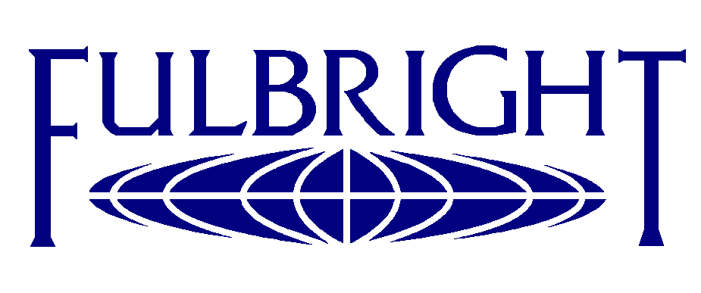
2011 International Education Week
a conference on
Educational and Cultural Cooperation for a Better Future

Monday - November 14, 2011
Biblioteka Uniwersytetu Warszawskiego
ul. Dobra 56/66, Warszawa, Room 316

11:00-11:05 Welcome, Introductions

Professor Włodzimierz Lengauer , Vice Rector of University of Warsaw

11:05-11:25 Educational Policy of the United States
DCM? Counselor for Press and Culture, U.S. Embassy

11:25-11:45 New Student Scholarship Programs of the Fulbright Commission: A gate to U.S. studies for graduate students from Poland and USA
Andrzej Dakowski, Executive Director

11:45-12:05 Academic linkages: joint research projects and students mobility as development strategy of modern university – Dr Monika Suchowierska , SWPS

12:05-12:25 The Kosciuszko Foundation Scholarships - Joseph Herter, Representative

12:25-12:45 Academic and cultural exchange as a road to a better future - Fulbright Professor

12:40-13:30 Lunch Break

13:30-14:00 Panel: How the Polish – U.S. Academic Partnership Programs help in building a better future.
Polish Fulbright Alumni and U.S. Fulbright Scholars and Students.

14:00-14:15 Conclusions. Wrap up.

