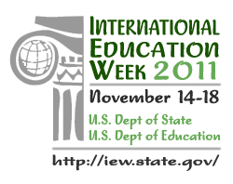

STUDIES IN THE USA

14 listopada, 2011

Biblioteka Uniwersytetu Warszawskiego, ul. Dobra 55/56
Room 316

15:00 – 15:15 Introductions

15:15 – 15:30 Icebreaking TBA

15:30 – 16:10 Panel: American Fulbright Students speak on the offer of the U.S. universities and life on campus

16:10 – 16:30 Student Visas U.S. Consul
TBA

16:30 – 16:50 Funding for U.S. Studies - Educational Resources on Internet
Maria Brzostek, Educational Advisor, Consulate General Kraków

16:50 – 17:10 How to Prepare a Winning Application
Magdalena Biela, Educational Advisor, U.S. Embassy

17:10 – 17:30 Internships in the United States for Polish Students
Ola Augustyniak, Educational Advisor, Polish – U.S. Fulbright Commission

17:30 – 17:50 Q&A

17:50 – 18:00 Wrap-up. Thanks

